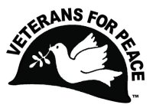Veterans For Peace - Chapter 93

May 2023 Newsletter
… The Utah Phillips – J. David Singer Chapter

Serving Washtenaw, Livingston, Hillsdale, Lenawee, and Jackson Counties.

Local Contact: Bill Shea – 734-662-0818 (cell/text) – billshea@umich.edu
www.vfp93.org or on Facebook at www.facebook.com/VFP93

1. Next Veterans For Peace Chapter 93 Meeting – Wednesday, May 16th, 7:30pm
The next VFP Chapter 93 meeting will be held online only, Wednesday, May 16th, at 7:30pm. If you would like to participate in the meeting online and your computer has a microphone and video, go to the Zoom meeting link of https://zoom.us/j/95022299743 No computer access or computer problems? Dial 312-626-6799 and enter the Meeting ID of 950 2229 9743 if prompted,. Anyone can participate in this meeting, or any other VFP Chapter 93 event, be they veteran or not. The meeting agenda is as follows…

- Introductions and welcome
- General Business
  - Previous meeting minutes
  - Treasury report
  - Membership
  - VFP 93 Calendar - May 14; Mother’s Day - May 15; Utah Phillips (Chapter namesake) birthday,
  - Other
- Old & continuing business
  - Honorary Chapter member program
  - Full Disclosure Recruiting
  - Michigan Peace Alliance
  - Washtenaw County Council of Veterans
  - Camp Grayling expansion – Draft VFP Chapter 93 opposition statement to expansion.
  - VFP Golden Rule sailboat stop at Detroit
  - Other
- New Business
  - Other
- Projects
  - Peace Studies Scholarship
  - MLK Day - January
  - Earth Day – Sunday, April 23 - Ann Arbor Leslie Science Center 12pm to 4pm
  - Peace Pole
  - Arlington Michigan – May & November
  - Ann Arbor Art Fair – July 20, 21, 22
  - Concert For Peace – October 12, 2023
  - Other
- Upcoming events/announcements
- Next meeting
- Adjournment

2. VFP Chapter 93 Meeting Minutes: April 19th, 2023
- Introductions and welcome - Meeting began at 4:02pm online over Zoom. Present were Mike Muha, Bill Shea, Bob Krzewinski, Steve Morehouse
- General Business
      - Previous meeting minutes – Accepted
      - Treasury report - Mike reported $70,013.65 in the Bank of Ann Arbor and $50 in a PayPal account. A recent expenses was for a $150 fee for rental of Ann Arbor Veterans Park for the VFP Veteran Day Arlington Michigan display.
      - Membership – The national office of VFP has new membership software that indicated in February the Chapter had 24 members and for March, nine members. For April membership, the number was 18 members. BOB will look into any errors and send emails to lapsed member urging them to renew their membership.
      - VFP 93 Calendar April 22nd Earth Day ; May 15th Utah Phillips birthday (Chapter namesake). Also discussed was educating the public about the peace origins of Mother’s Day (May 14).
- Old & continuing business
      - Honorary Chapter member program – No recommendations at this time.
      - Full Disclosure Recruiting –BILL and STEVE will be staffing a VFP Ann Arbor Pioneer High School Full Disclosure table at their career fair on April 17th from 6pm-7:30pm.
      - Michigan Peace Alliance – Bill gave a report on the groups action.
      - Washtenaw County Council of Veterans – BILL will attend meetings when possible.
      - Camp Grayling expansion – Draft VFP Chapter 93 opposition statement to base expansion. BOB is updating a draft resolution to include fact checking and add bookmarks and return it to Chapter 93 for final approval no later than the next meeting.
      - VFP Golden Rule sailboat stop at Detroit – New dates for the arrival of the Golden Rule include a stop at Toledo on August 10-13 and then in Detroit for a visit on August 13-17. Jim Rine from the Metro Detroit VFP will be coordinating the visit and can be reached at jimrine22@gmail.com or 281-414-1386 (cell/text).
- New Business
      - No new business. .
- Projects
      - Peace Studies Scholarship – BILL reported no new applications.
      - MLK Day – January – No new news.
      - Earth Day – Chapter will be at the Ann Arbor Earth Day event on Sunday, April 23rd at the Leslie Science Center.
      - Peace Pole – No new news.
      - Arlington Michigan – May & November – BOB reported that a permit application was approved submitted for a May Memorial Day display in Detroit’s Grand Circus Park.
      - Concert For Peace – October 12, 2023 – BILL talked with Chris Buhalis and Chris is on board for an October 12th concert at The Ark.

6) Upcoming events/announcements – None.
7) Next meeting – Tuesday, May 16th, 2023, 7:30pm online Zoom meeting.
8) Adjournment – Meeting adjourned at 4:58pm

3. VFP Arlington Michigan Display In Downtown Detroit On Memorial Day – May 29th
Veterans For Peace Chapters 74 and 93 have again joined forces to set up the VFP Arlington Michigan display (one grave marker for every Michigan soldier killed in the Afghan and Iraq wars – 230 total) in downtown Detroit on Memorial Day, Monday, May 29th. The purpose of this display is to honor those who have fallen, to provide a place to grieve, and to educate the public about the costs of war, as well as the needs of those returning from conflicts. The display will be held on May 29th, 11am to 5pm, in downtown Detroit’s Grand Circus Park (Woodward at East Adams – map link at https://goo.gl/maps/MjhWcB4ospmmwwFu6).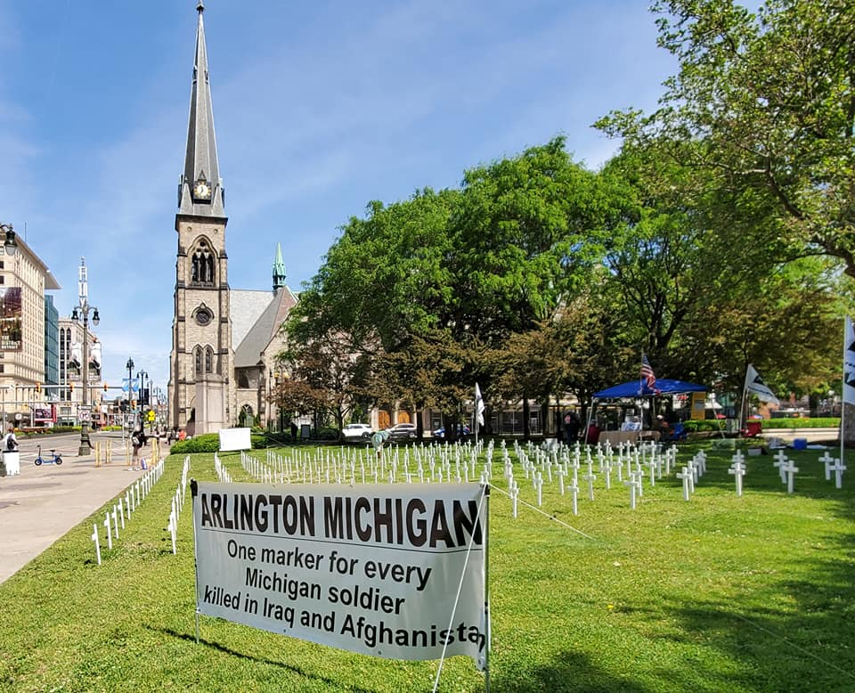

4. VFP Golden Rule Visit To Detroit Update
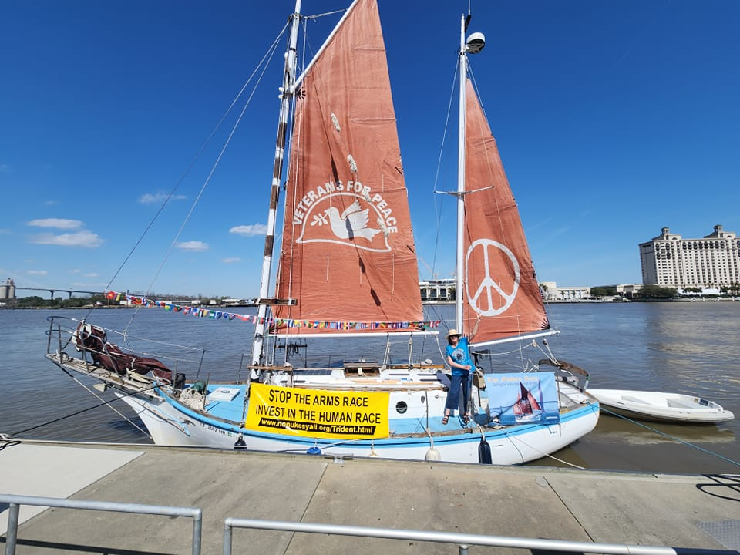This summer, the VFP-restored Golden Rule, which set sail in 1958 to stop nuclear weapons testing in the Marshall Islands and inspired many peace makers and peace ships that followed, will sail through the Great Lakes including a stop in Detroit (13-17 August 2023; http://www.vfpgoldenruleproject.org). Afternoon tours of the Golden Rule will be at William G. Milliken State Park and Harbor (website at https://www2.dnr.state.mi.us/parksandtrails/Details.aspx?type=SPRK&id=697). Along with festivities and talks in Detroit on August 13th and 16th, the crew will visit Lansing (August 14th) and Ann Arbor (August 16th).

Also, there is a real need of donations to keep the Golden Rule operating and also pay for expenses associated with the Detroit stop (lodging, local transportation, meals, etc.). Tax deductible donations can be made at https://www.gofundme.com/f/veterans-for-peace-golden-rule-in-detroit. Every dollar you donate will go directly to support the Golden Rule's trip and mission. Thank you.

For more information on the Golden Rule, along with an interactive map, visit https://vfpgoldenruleproject.org. or visit their Facebook page at https://www.facebook.com/GoldenRulePeaceBoat.

5. Michigan Rejects Camp Grayling Expansion – Instead Offers Annual Use Permits
On Friday, April 28th, The Bridge Michigan news service reported that the Michigan Department of Natural Resources has rejected a request to double the footprint of the Camp Grayling military training base, instead opting to make up to 52,000 acres of state land available for the military’s short-term use.

Officials with the Michigan Army National Guard last year requested a 20-year lease on 162,000 acres for what it called low-impact training activities in modern cyber, air and space warfare. That enraged area residents and environmentalists, who questioned why the Guard needs more space beyond the 148,000 acres already at its disposal at the Camp Grayling Joint Maneuver Training Center.

In a statement on Friday, April 28th, Acting DNR Director Shannon Lott said comments from the proposal’s opponents — which included dozens of objections from local governments, outdoors and environmental groups (as well as Veterans For Peace Chapters 74 & 93) — prompted the DNR’s scaled-back approach. “We appreciate the many comments we received on this proposal and the commitment people have to public lands,” Lott said. “Public concerns and feedback from Tribal governments, coupled with our own review of the proposal, led us to decide against a 20-year lease on such a significant portion of state-managed land.” For more on this story visit https://www.bridgemi.com/michigan-environment-watch/michigan-rejects-camp-grayling-expansion-instead-offering-annual-use

6. Beyond Earth Day Online Program – Saturday, May 13th
Beyond Earth Day Webinar: New Initiatives of VFP’s Climate Crisis & Militarism (CCMP) - May 14 – 4pm EDT. The MC is VFP Membership Coordinator Jules Vaquera, who will sing and also feature a music video. Speakers and topics are - Gary Butterfield, NO MAS (No Military Air Shows) project; Ian Mooney, outreach to youth; climate activists; Steve Morse, Just Transition project; Cindy Priester, overview of COP27; Jim Rine, Stop War, Save Climate project.
Register at https://us06web.zoom.us/webinar/register/WN_lrJZU9a2TQa_BJJdE2uxWw

7. Website Recommendations
- The Radical Origin Of Mother’s Day - There’s a good number of people who question holidays like Mother’s Day in which you spend more time feeding money into a system that exploits our love for our mothers than actually celebrating them. It’s not unlike any other holiday in America in that its complete commercialization has stripped away so much of its genuine meaning, as well its history. Mother’s Day is unique in its completely radical and totally feminist history, as much as it has been forgotten. https://www.codepink.org/the_radical_history_of_mother_s_day

- Georgia National Guard Will Use Phone Location Tracking To Recruit High School Children - The Georgia Army National Guard plans to combine two deeply controversial practices — military recruiting at schools and location-based phone surveillance — to persuade teens to enlist, according to contract documents reviewed by The Intercept news service. https://theintercept.com/2023/04/16/georgia-army-national-guard-location-tracking-high-school/

- Daniel Ellsberg, Who Leaked The Pentagon Papers, Announces He Has Terminal Cancer
Daniel Ellsberg, who copied and leaked documents that revealed secret details of U.S. strategy in the Vietnam War and became known as the Pentagon Papers, has announced he has terminal cancer and months to live. https://www.npr.org/2023/03/03/1160850456/daniel-ellsberg-who-leaked-the-pentagon-papers-announces-he-has-terminal-cancer

8. Quote Of The Month…
“For an American to be patriotic is to be loyal to the principles of our Constitution, and the First Amendment. The truth is that the policies of the government is sometimes in conflict with that. In our country, patriotism should not be defined as obedience to an authority.” — Daniel Ellsberg

9. Announcement, Anniversaries & Reminders
Every Friday – Ann Arbor Anti-War Rally
The Ann Arbor Committee Against War (AACAW) has been gathering for small anti-war rallies every Friday at 5:30 pm, and we always welcome everyone to join them at the Federal Building. For more information about the AACAW visit https://www.annarborcoalitionagainstwar.org

Veterans For Peace National Weekly E-News List
Veterans For Peace puts out a weekly eNews that features a weekly summary of news from Veterans For Peace members, chapters and the National office. To sign up for the Weekly eNews, click here!

VFP John Lennon Birthday Benefit Concert CD
Our VFP Chapter has a compact disc (CD) recording of the musical artists performing at our October John Lennon Birthday Benefit Concerts over the years for our Chapter’s Peace Scholarship program. And like the Concert, a purchase of the CD also goes to benefit the Peace Scholarship program. The John Lennon Birthday Benefit Concert CD can be purchased for $15, plus $3 for shipping, by PayPal by visiting www.vfp93.org/john-lennon-concert-cd.

Selections on the John Lennon CD include Revolution (Chris Buhalis, Peter “Madcat” Ruth), Maggie Mae (Dave Boutette, Peter “Madcat” Ruth, Dave Keeney), You’ve Go To Hide Your Love Away (Annie & Rod Capps, Jason Dennie), Lucy In The Sky With Diamonds (Billy King with Emily Slomovits and band), In My Life (Emily Slomvits with Billy King), Dear Prudence (Jo Serrapere), Across The Universe (Jen Sygit), Rest Easy Little Darlin (John Latini), Crippled Inside (Dave Keeney, Sophia Hanfi), Working Class Hero (Rochelle Clark), Come Together (Shari Kane and Dave Steele) and Imagine (Billy King).

Metro Detroit VFP Chapter
The Metro Detroit Chapter of Veterans For Peace covers Wayne, Oakland, Macomb, and Monroe Counties and also has regular meetings. For more information visit https://www.vfp74.org.

Our VFP Chapter Can Use Your Help
Currently our VFP Chapter has only a few people doing all the work and projects and to say we could use help is an understatement. Most of these jobs don’t take up that much time at all, and would help out the Chapter immensely. One thing we are trying to promote is for people to sign up for a “volunteer email list.” We always need extra people to help staff events like the Arlington Michigan display on Memorial/Veterans Day or the VFP booth at Earth Day or the Ann Arbor Art Fair. Just tell us you want to be on the volunteer e-mail list and when an event date starts rolling around, we will email you to see if you can help out. If you can, great. If not, we understand. Even if you are not a veteran, we could still use your help.

To be placed on the “volunteer email list,” just send an email to Bob Krzewinski at wolverbob@gmail.com and he will get back in touch with you. Thanks in advance for your consideration of this request!!!

Thinking About Joining The Military? Already In The Military Seeking Conscientious Objector Status, Delayed Enlistment Problems, Or Release From Service?
Visit our “Thinking About Joining The Military? - Please Read This First” web page at www.vfp93.org/military-recruiting. The page includes before enlisting, how you should be able to honestly answer some basic questions, and have realistic expectations, about military life, a link to the 24-hour ​GI Rights Hotline for people already in the military, and a link to Project YANO (Youth And Non-Military Opportunities) with information about military enlistments, the delayed entry program, and resources for alternatives to the military. Also, you will find a link to the Center On Conscience And War which has information on Selective Service registration, the draft, and conscientious objector status.

